**Property Binding [ ]**

* ***Property binding flows a value in one direction, from a component's property into a target element property.***
* ***You can't use property binding to read or pull values out of target elements.***
* ***Similarly, you cannot use property binding to call a method on the target element.***
* ***Use property binding to*set*properties of target elements or directive @***[***Input***](https://angular.io/api/core/Input)***() decorators.***
* ***If the element raises events, you can listen to them with an***[***event binding***](https://angular.io/guide/event-binding)***.***
* ***Property binding is a one-way mechanism that lets you set the property of a view element.***
* ***It involves updating the value of a property in the component and binding it to an element in the view template.***
* ***. Property binding uses the [] syntax for data binding.***
* ***Property binding is a technique, which will help to bind values to the properties of HTML elements.***
* ***In Angular property binding is used to pass data from the component class (component.ts) and setting the value of the given element in the user-end (component.html).***
* ***Property binding is an example of one-way databinding where the data is transferred from the component to the class.***

***Example::1***

***app.component.ts***

import { Component } from '@angular/core';

@Component({

  selector: 'app-root',

  templateUrl: './app.component.html',

  styleUrls: ['./app.component.css']

})

export class AppComponent {

  title = 'AngularTasks';

  imageBinding="PropertyBinding";

  image:string="https://cdn.searchenginejournal.com/wp-content/uploads/2019/04/the-seo-guide-to-angular-760x400.png";

}

***app.component.html***

<!DOCTYPE html>

<html lang="en">

<head>

  <meta charset="UTF-8">

  <meta name="viewport" content="width=device-width, initial-scale=1.0">

  <title>Document</title>

</head>

<body>

  <div class="container">

    <h1 style="text-align: center;">{{imageBinding}}</h1>

    <img [src]="image" alt="angular-image" width="50%"  height="50%">

  </div>

</body>

</html>

***BrowserOutput::***

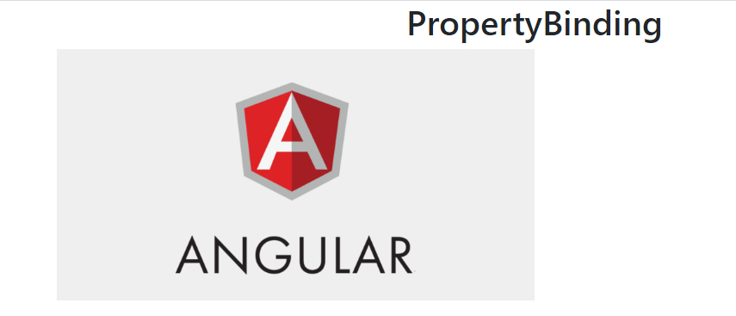

***ExecutionFlow::***

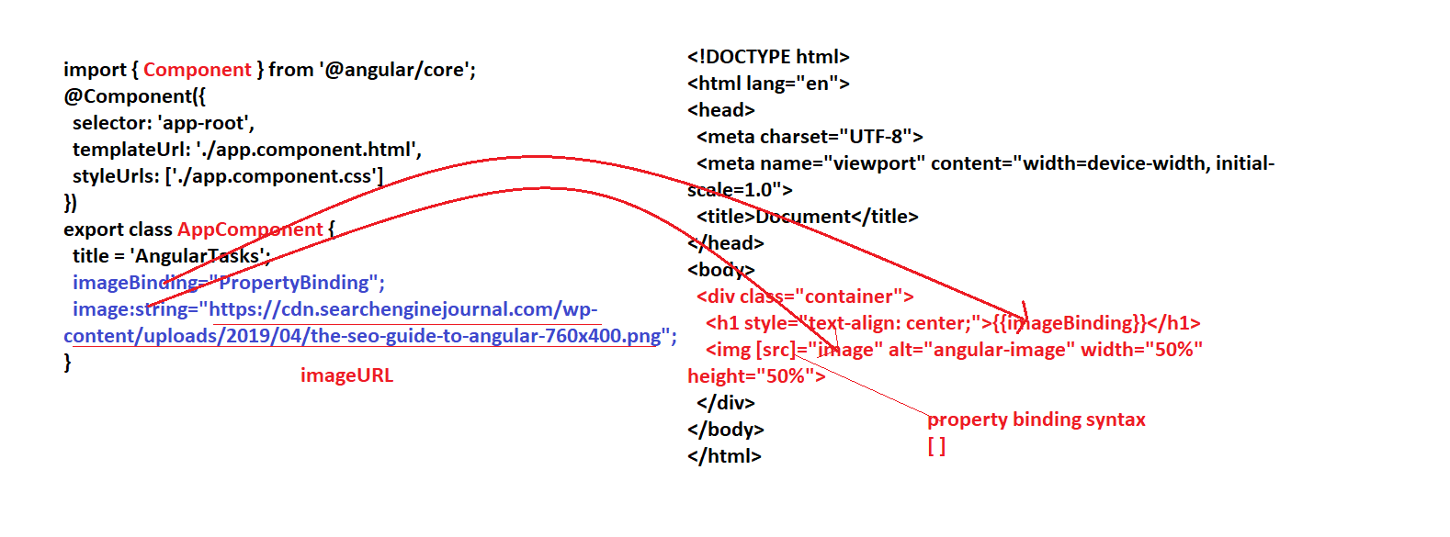

***Example:2***

***app.component.ts***

import { Component } from '@angular/core';

@Component({

  selector: 'app-root',

  templateUrl: './app.component.html',

  styleUrls: ['./app.component.css']

})

export class AppComponent {

  title = 'AngularTasks';

  propertyBinding="PropertyBinding"

  headingTwo="text-align: center;color:red;font-style:italic;font-weight:bold;padding:20px;background-color:black;width:45%";

}

***app.component.html***

<!DOCTYPE html>

<html lang="en">

<head>

  <meta charset="UTF-8">

  <meta name="viewport" content="width=device-width, initial-scale=1.0">

  <title>Document</title>

</head>

<body>

  <div class="container">

 <h1 style="text-align: center;">{{propertyBinding}}</h1><!--No binding -->

 <h2 [style]="headingTwo">am abhinay</h2>

  </div>

</body>

</html>

***BrowserOutput::***



***Example:3***

***app.component.ts***

import { Component } from '@angular/core';

@Component({

  selector: 'app-root',

  templateUrl: './app.component.html',

  styleUrls: ['./app.component.css']

})

export class AppComponent {

  title = 'AngularTasks';

  isActive="false";

}

***app.component.html***

<!DOCTYPE html>

<html lang="en">

<head>

  <meta charset="UTF-8">

  <meta name="viewport" content="width=device-width, initial-scale=1.0">

  <title>Document</title>

</head>

<body>

  <div class="container">

<div class="text-center">

  <h2>Property Binding</h2>

  <button [disabled]="isActive" class="btn btn-primary">GO</button>&nbsp;&nbsp;

  <button [disabled]="!isActive" class="btn btn-primary">GO</button>

</div>

  </div>

</body>

</html>

***Browser Output::***



***Example:4***

***app.component.ts***

import { Component } from '@angular/core';

@Component({

  selector: 'app-root',

  templateUrl: './app.component.html',

  styleUrls: ['./app.component.css']

})

export class AppComponent {

  title = 'AngularTasks';

  link1="https://facebook.com";

  link2="https://flipkart.com";

}

***app.component.html***

<!DOCTYPE html>

<html lang="en">

<head>

  <meta charset="UTF-8">

  <meta name="viewport" content="width=device-width, initial-scale=1.0">

  <title>Document</title>

</head>

<body>

  <div class="container">

<div class="text-center">

  <h2>Property Binding</h2>

  <!-- <a href="https:facebook.com">Facebook</a>

  <a href="https:facebook.com">Flipcart</a> -->

    <a [href]="link1">Facebook</a><br>

    <a [href]="link2">Flipkart</a>

</div>

  </div>

</body>

</html>

***Browser output:::***



***When we click on Facebook it redirects to Facebook page***

***When we click on Flipkart it redirects to Flipkart page***

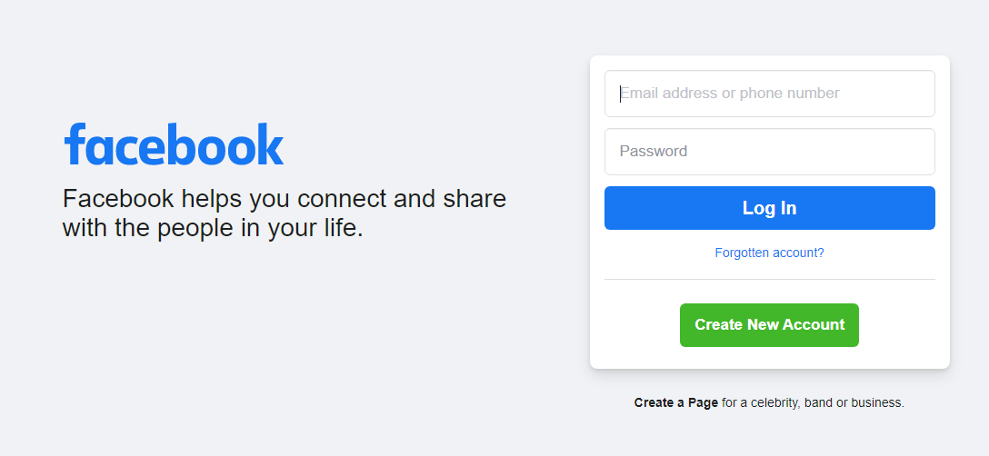

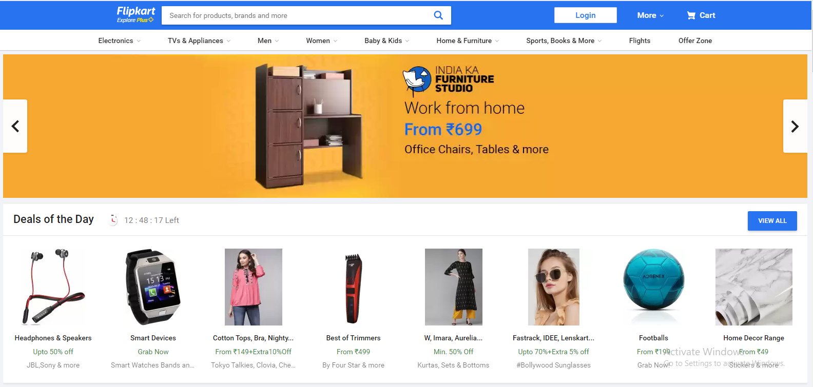

***Example:5***

***app.component.ts***

import { Component } from '@angular/core';

@Component({

  selector: 'app-root',

  templateUrl: './app.component.html',

  styleUrls: ['./app.component.css']

})

export class AppComponent {

  title = 'AngularTasks';

  type="number";

  name="username"

  id="userId";

  placeholder="enter user name";

  bClass="form-control";

***app.component.html***

<!DOCTYPE html>

<html lang="en">

<head>

  <meta charset="UTF-8">

  <meta name="viewport" content="width=device-width, initial-scale=1.0">

  <title>Document</title>

</head>

<body>

  <div class="container">

  <h2>Property Binding</h2>

 <div class="col-sm-3">

   <input [type]="type" [name]="name" [id]="id"  [placeholder]="placeholder" [class]="bClass"  >

 </div>

  </div>

</body>

</html>

***Browser Output***

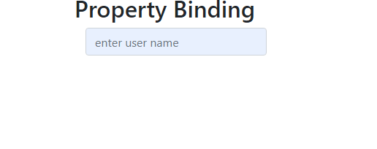

***Example:6***

***app.component.html***

<!DOCTYPE html>

<html lang="en">

<head>

  <meta charset="UTF-8">

  <meta name="viewport" content="width=device-width, initial-scale=1.0">

  <title>Document</title>

</head>

<body>

  <div class="container">

 <h2>Property Binding</h2>

    <p [hidden]="true">Lorem ipsum dolor sit amet consectetur adipisicing elit. Vitae incidunt assumenda voluptatibus architecto provident officia at molestias, tempore mollitia dignissimos fuga, vel doloremque deleniti praesentium cum dicta maiores odit cumque.</p>

    <p [hidden]="false">Lorem ipsum dolor sit amet consectetur adipisicing elit. Vitae incidunt assumenda voluptatibus architecto provident officia at molestias, tempore mollitia dignissimos fuga, vel doloremque deleniti praesentium cum dicta maiores odit cumque.</p>

  </div>

</body>

</html>

***Browser Output***

